Guide2. APT Project Development
Capstone Subject

1. Summary of APT Project Progress
Below, you will find different fields that you must fill in with the requested information.

APT Project Progress Summary | During Phase 2, the architectural transition of the ClearBid NJ (Pre-Bid Intelligence System for Real Estate Auctions) project was executed from a monolithic environment of local validation to a distributed, containerized and persistently connected architecture in the cloud. The technical development of the team was consolidated in four fundamental and verifiable pillars:  - Relational Persistence and Cloud Migration (PostgreSQL 16 -> Supabase): Initially, the relational schema clearbid_db 25 tables was deployed and validated in local PostgreSQL 16 with pgAdmin 4 and Alembic (v1.14.0), verifying credentials with Argon2id hash (v=19...) and 3 initial properties. Subsequently, the data layer was migrated to a managed instance in Supabase Cloud (aws-0-us-east-1.pooler.supabase.com:5432) operating with asynchronous SQLAlchemy 2.0.36. There the nuclear tables (properties, property_financials, property_legal, property_physical, traffic_light_results and rule_results) were populated with 11 Mercer County auction properties, including the actual case study drawn from the county's public records: $argon2id$4216 Nottingham Way, Hamilton Twp (Block 1853, Lot 19).  - Backend API REST and Security (FastAPI + JWT + 2FA OTP): The backend server was implemented on top of FastAPI (v0.115.5) and Uvicorn (v0.32.1) on port 8000, structuring versioned endpoints (/api/v1/) for catalog query, financial evaluation (Opening Bid, ARV, ROI), risk traffic light calculation and authentication. In cybersecurity, the 2FA verification flow evolved from a simulated local validator to a real 6-digit OTP code dispatch service via email (SMTP) integrated into the b2f8fe5 commit, operating together with rotating JWT tokens.  - Containerized Infrastructure and Asynchronous Services (Docker + Redis + Celery): The backend was orchestrated using Docker Compose on lightweight images python:3.12-slim and alpine, deploying three services: the main container backend-api-1 (FastAPI + Alembic at boot), the backend-redis in-memory broker (redis:7-alpine v7.4.11 on port 6379) and the background processor backend-worker running Celery (v5.6.3 with 8 prefork processes). Likewise, the battery of automated tests with Pytest (v8.3.4) was executed inside the container (10 tests in 1.66s: 7 PASSED and 3 FAILED), identifying validation gaps in authentication before going to production.  - Frontend SPA and End-to-End Integration (React 18 + TypeScript + Vite): The web application was built and connected using React 18, TypeScript, Tailwind CSS, Zustand, and TanStack Query on port 5173 (exposed on GitHub Codespaces and pre-published on Netlify). After resolving serialization conflicts with Pydantic and populating the child tables in Supabase, the interface dynamically renders the 11 Mercer County properties with their risk indicators, open prices, ARV, ROI calculation (+15.95% for 4216 Nottingham Way), side filters, and the full OTP-validated login flow received in Gmail.
Objectives | - General Objective: To develop and validate a functional and integrated prototype of the ClearBid NJ platform (Frontend SPA, asynchronous REST API, relational cloud database and container architecture) that centralizes financial, physical and legal data of properties at auction in New Jersey, automating pre-bid classification through a risk traffic light engine.  - Specific Objectives of Phase 2:  - Implement relational persistence and schema migrations: Accomplished. The schema of 25 tables was designed in local PostgreSQL 16 with Alembic and the operational structure was migrated to Supabase Cloud (uxaeutpgbwunpwpgmvio), solving incompatibilities of foreign keys (VARCHAR vs bigint) and populating 11 properties in Mercer County with their child tables.  - Build the modular REST API and the secure authentication flow: Partially complied (85%). The property endpoints, risk traffic light, registration with Argon2id hashing, JWT login and 2FA OTP challenge via email are in operation, pending for Phase 3 to correct 3 HTTP status code assertions (401 and 201) detected by Pytest in /api/v1/auth.  - Orchestrate container infrastructure and asynchronous work queues: Fulfilled (100%). The backend environment operates reproducibly under docker compose up by integrating FastAPI, Redis 7 and Celery Worker (8 processes), deprecating the local database container to connect directly to the Supabase IPv4 Pooler.  - Integrate the React + TypeScript Frontend interface with the Backend and Supabase: Fulfilled in the main flow (90%). The Dashboard consumes the real data from FastAPI/Supabase in GitHub Codespaces, displaying the list of auctions, filters and traffic light status without load blocking (Loading...), remaining to consolidate in Phase 3 the advanced geospatial views (Leaflet/PostGIS) and the administrative ingestion panel.
Methodology | Although the initial planning of Phase 1 established the Scrum framework with biweekly Sprints supported by Trello, the operational reality of the team – marked by the effective start in Week 3 and the incompatibility of time blocks due to professional practices – required adapting the process towards an asynchronous modular engineering model and transversal collaboration.  Instead of keeping track in Trello, coordination and traceability were executed directly on top of the GitHub repository (Pruebas_Proyecto_ClearBidNJ), cloud environments (GitHub Codespaces, Supabase and Netlify) and technical handover documentation. Although the repository was structured in five branches (main, feature/backend, feature/data-engine, feature/devops-qa and feature/frontend), the resolution of blocking dependencies led the members to collaborate transversally:  - Felipe Calderón (Local DB & Initial Model): Survey of local PostgreSQL 16 (clearbid_db with 25 tables), persistence verification with Argon2id encryption in pgAdmin 4 and registry-database connection tests with the first 3 properties.  - Alfredo Castro (Initial Cloud Architecture & Management): Configuration of the cloud instance in Supabase (uxaeutpgbwunpwpgmvio), structuring of the initial log load and first demonstration deployment in Netlify.  - Matías Tirado (DevOps, Asynchronous Services & QA): Designed and built Docker Compose (API, Redis and Celery Worker), solved IPv6 network blocking and data type conversion (bigint to VARCHAR) in Alembic to Supabase, and executed QA audit with Pytest.  - Cristopher Hernández (Frontend SPA, OTP Integration & Security): Developed the React/TypeScript/Vite interface, worked transversally in backend/security (commit b2f8fe5 in feature/frontend) implementing the sending of OTP codes by email (SMTP), normalized the data in Supabase and integrated the real case #11 (4216 Nottingham Way) in Codespaces.
Evidence of progress | The following are the executive technical evidences that support the integrated advancement of the components of the system:  - Evidence 1: Local Database and Hashing Argon2id (pgAdmin 4 / PostgreSQL 16)  SQL query on the public.users table in the clearbid_db database that demonstrates user persistence and password safeguarding using Argon2id cryptographic hashing.  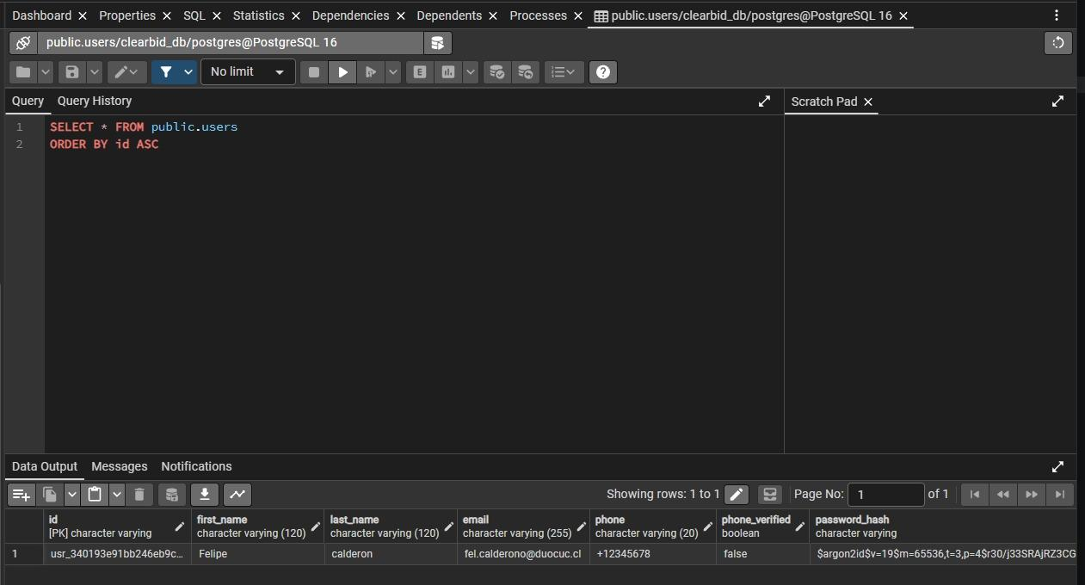  Figure 1: User persistence check and Argon2id hash in pgAdmin 4 (PostgreSQL 16).  - Evidence 2: Containerization, Asynchronous Queues and Cloud Connection (Docker + Redis + Celery)  Docker compose up execution demonstrating the automatic start of migrations with Alembic (0001_initial) and the start-up of the FastAPI server on port 8000 inside the api-1 container.  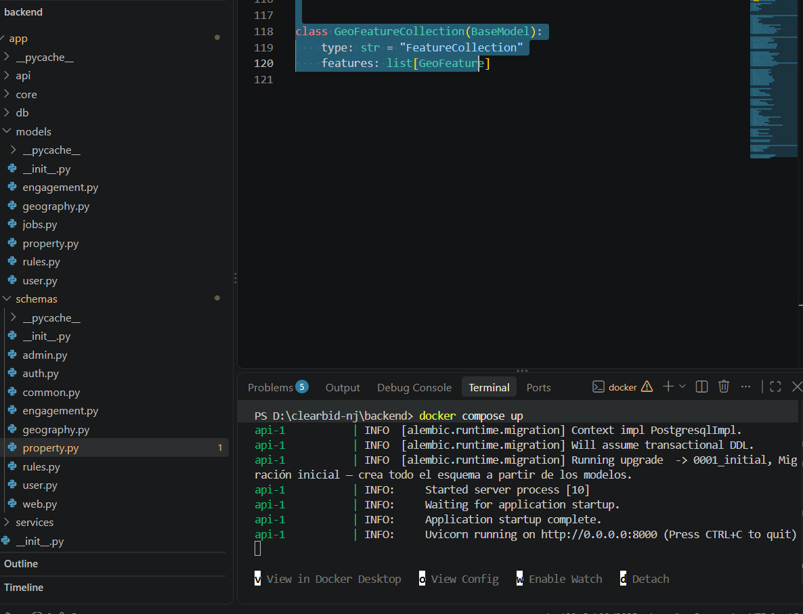  Figure 2: Docker Compose container orchestration running Alembic and FastAPI Uvicorn.  - Evidence 3: Automated QA Audit (Pytest)  Registration of the unit and integration test suite executed with Pytest (tests/test_auth.py), obtaining a result of 7 approved tests and isolating 3 assertion failures in the HTTP authentication response codes (assert 200 == 401 and assert 200 == 201) for remediation.  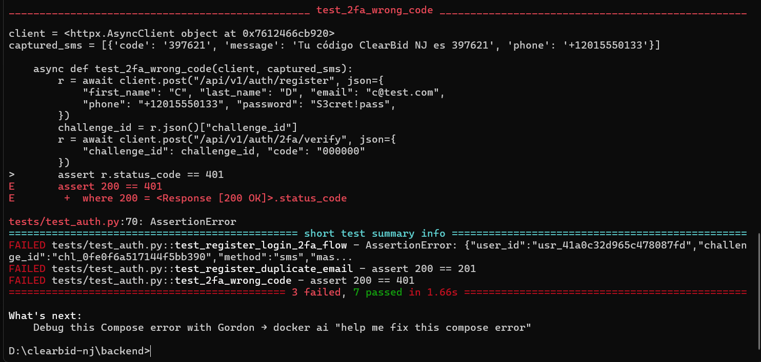  Figure 3: Result of the automated test suite with Pytest (7 PASSED, 3 FAILED) in tests/test_auth.py.  - Evidence 4: Relational Architecture and Persistence in Supabase Cloud  Visualization of the database managed in Supabase (project uxaeutpgbwunpwpgmvio) displaying the relational schema of foreign keys in the Schema Visualizer and the catalog of 11 active records of Mercer County populated in the properties table within the Table Editor.  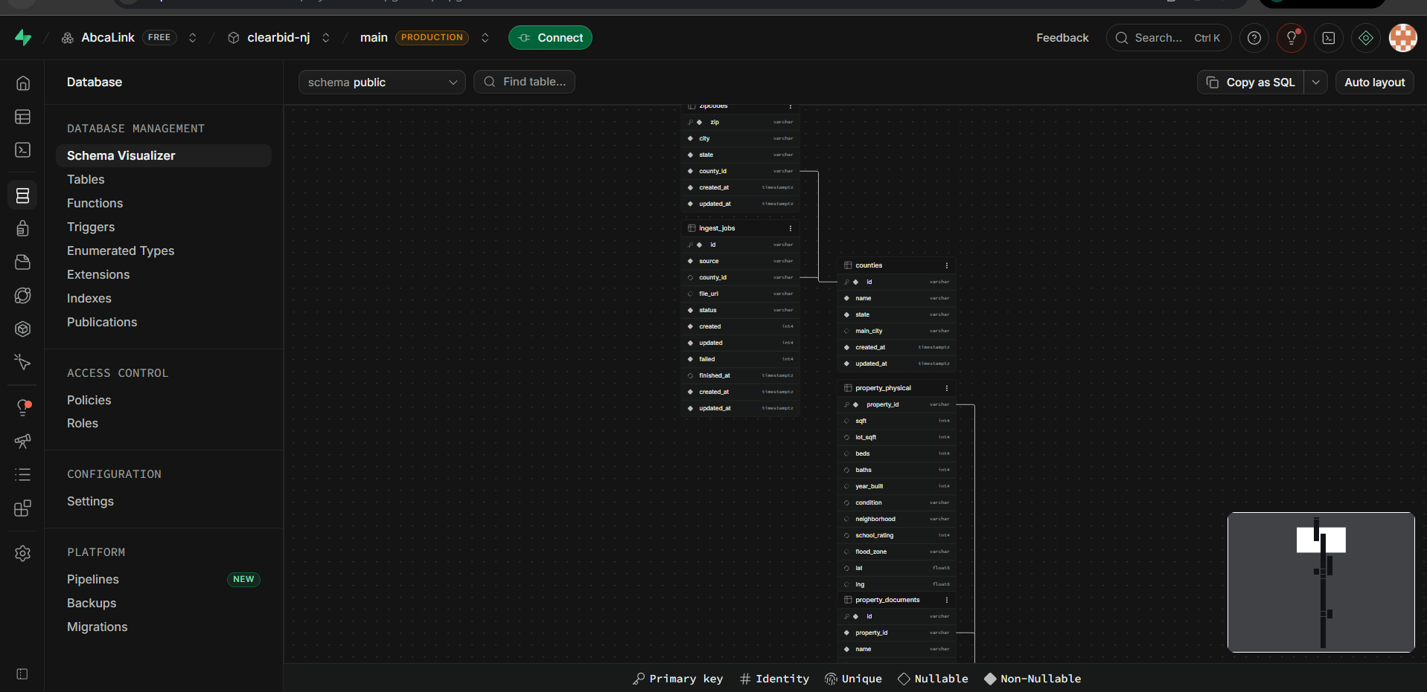  Figure 4: ERD diagram and records of the public.properties table in Supabase Cloud.  - Evidence 5: JWT Security Flow + 2FA OTP via Email (SMTP)  Secure authentication sequence where the user enters their credentials in React, the FastAPI Backend generates a 6-digit OTP challenge, sends the mail via SMTP to Gmail and validates the code to authorize the session.  - The corresponding credentials are entered.  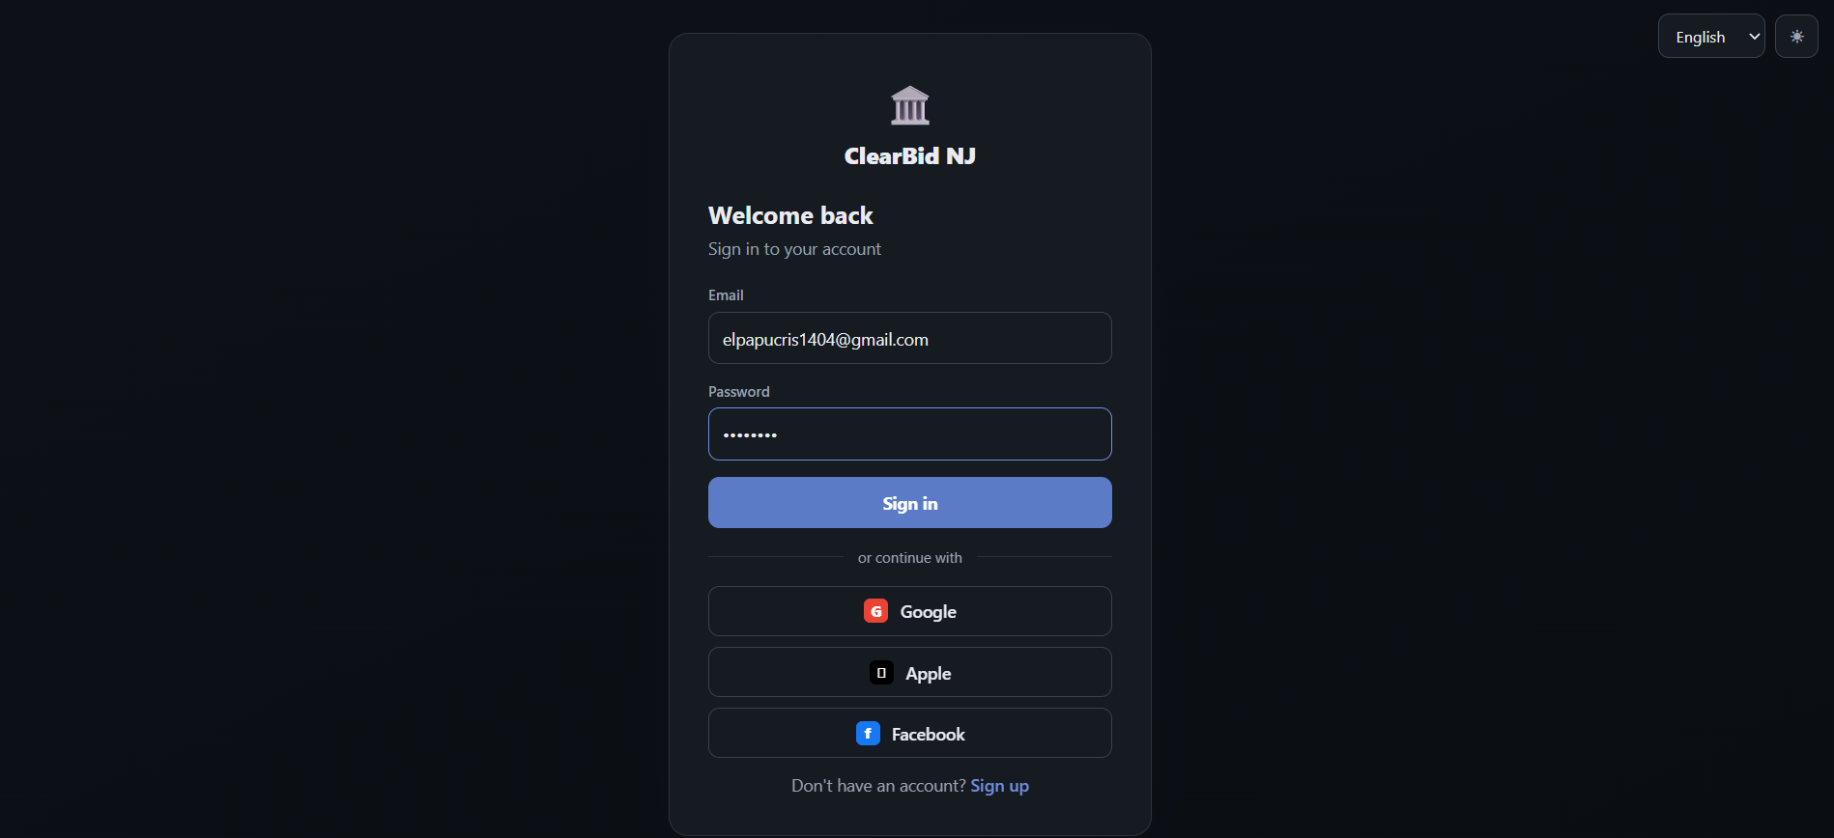  - Selecting the "Sign In" button will redirect you to the code section, where you expect the code to arrive in the email.  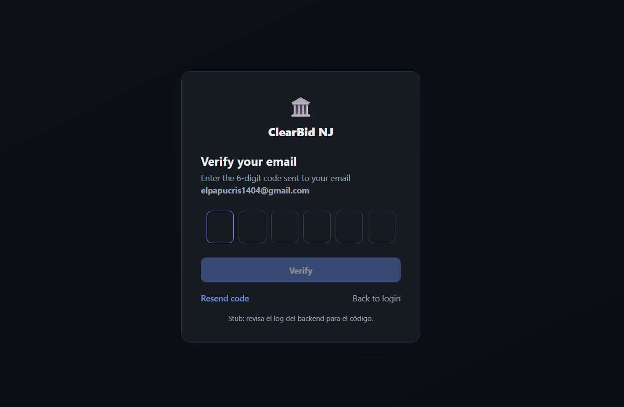  - It can be seen that the mail arrives directly to the inbox, where the access code is allowed to be seen.  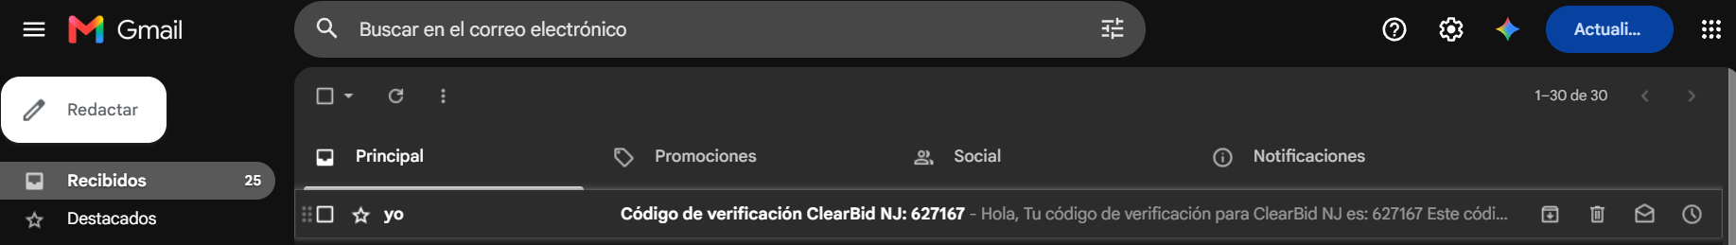  Figure 5: End-to-End sequence of the 2FA OTP security flow sent via email.  6. Evidence 6: End-to-End Integration into GitHub Codespaces and Dashboard Frontend  Final deployment of the web application (SPA React 18 / Vite) on port 5173 consuming the FastAPI REST API (port 8000), rendering the 11 Mercer County properties with their risk indicators, open prices and ROI calculation (+15.95% for 4216 Nottingham Way).  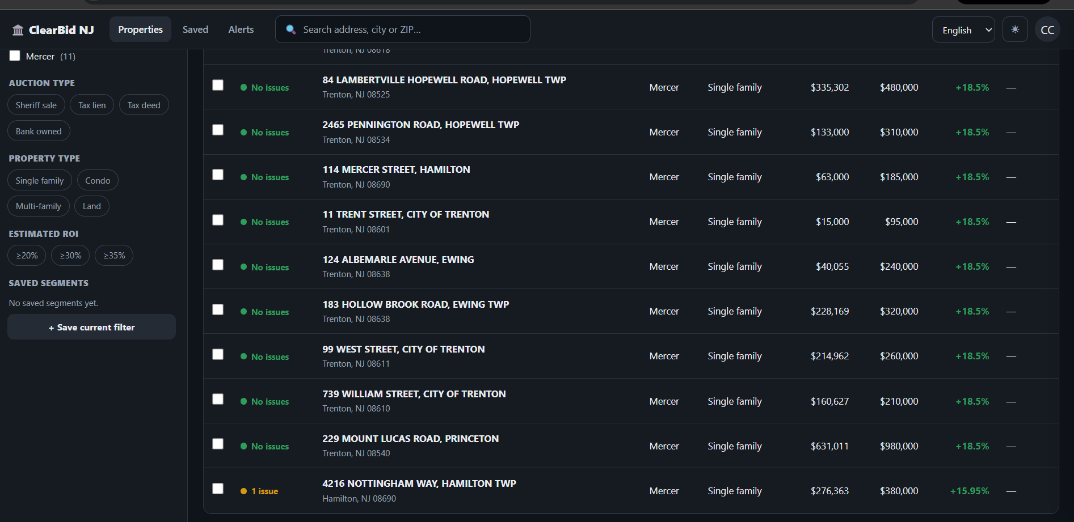  Figure 6: Interactive dashboard of ClearBid NJ consuming dynamic data from FastAPI and Supabase Cloud.

2. Monitoring the work plan
Carefully examine your work plan, focusing especially on the progress status and adjustments column.

Work Plan
Competence or units of competences | Activities | Resources | Duration of the activity | Responsible | Observations | Progress status | Settings
IT Project Management | Planning, Backlog and Coordination with Client | GitHub, Shared Docs | Weeks 1 - 3 | Alfredo Castro | The project effectively started in Week 3. Control was carried out through GitHub branches and asynchronous coordination. | Completed with fit | Track changes via commits/branches on GitHub, discarding Trello as active evidence.
DB Management and Modeling | Configuring PostgreSQL Local, Alembic and Migrating to Supabase | PostgreSQL 16, pgAdmin 4, Alembic 1.14, Supabase | Weeks 3 - 6 | Felipe Calderón | Felipe lifted clearbid_db home side (25 draws). Matías converted properties.id to VARCHAR; Cristopher normalized fields and populated the 11 properties in Supabase. | Completed in the cloud. | Synchronize normalization SQL scripts executed in Supabase in the feature/data-engine branch
Software Development / Cybersecurity | Development of Backend API REST API, Risk Engine and Auth JWT/2FA | Python 3.12, FastAPI 0.115, Pydantic, Argon2id, SMTP | Weeks 5 - 11 | Alfredo Castro & Cristopher Hernández | They operate catalog, traffic light and registry endpoints. Cristopher updated auth.py (commit b2f8fe5) replacing the phone stub with real OTP to Gmail. | Advanced (85%) - QA | Refactor driver responses to HTTP 401 and 201 to pass 100% of the Pytest battery
Web Development | Initialization and Development Frontend React + TypeScript and API Integration | React 18, Vite, Tailwind, Zustand, TanStack Query, Codespaces | Weeks 7 - 13 | Cristopher Hernández | Views connected to Supabase/FastAPI. Resolved 404 (ports) and 500 (Pydantic) errors. Deploys 11 auctions with ROI and semaphore. | Operational (90%) | Merge feature/frontend (commit b2f8fe5) to main using Pull Request for Phase 3 closure.
Quality, Security and DevOps | Comprehensive Containerization, Asynchronous Services (Redis/Celery) and QA Suite | Docker, Docker Compose, Redis 7.4, Celery 5.6, Pytest 8.3 | Weeks 10 - 15 | Matías Tirado | Orchestration of backend-api-1, backend-redis and backend-worker (8 processes) by IPv4 Pooler. Ran Pytest (7 PASSED, 3 FAILED) | Infra 100% / QA 70% | Upload docker-compose.yml settings in feature/devops-qa and re-run Pytest after the auth patch
Management / Closure | Phase 2 Closure, Evidence Consolidation and Milestone 3 | White paper, GitHub, PDF | Weeks 15 - 18 | The whole team | Formal evidence collection of BD, Docker/QA, and Frontend. Artifact cleanup identification | Ongoing (Phase 2 ok; Milestone 3 prod) | Delete .env files from the repository, rotate exposed credentials, and generate release tagged in main.

3. Adjustments from monitoring
Dig deeper into the observations in your work plan. Analyze the planned activities and point out what aspects facilitated or hindered the execution of the plan. Discuss how you addressed and/or will address the obstacles. Finally, point out the adjustments you made to the work plan based on this analysis.

Factors that have facilitated and/or hindered the development of my work plan:
Organizational and Data Difficulties: The main obstacle was the late start of the project (week 3) and the workload derived from the professional practices of the members, which reduced synchronous meeting times. Additionally, the initial scarcity of information from the client forced to structure a model with 3 simulated properties before populating the 11 final records of Mercer County in Supabase and investigating official sources (Mercer County Sheriff's Office and Mercer County Clerk RecordsNG) to document the real case of 4216 Nottingham Way.
Log of Resolved Technical Incidents:
- Alembic / BD Configuration (alembic/env.py): ValueError: invalid interpolation syntax. The password contained %. Solution: Escape the symbol in alembic/env.py (DATABASE_URL.replace('%', '%%')).
- Red Docker <-> Supabase Cloud: OSError: [Errno 101] Network is unreachable. The direct host resolved only in IPv6. Solution: Point to the Shared Connection Pooler IPv4 (aws-0-us-east-1.pooler.supabase.com:5432)
- Supabase Relational Schema:
DatatypeMismatchCrash error between VARCHAR and int8 in properties.id. Solution: Structural SQL migration (ALTER TABLE properties ALTER COLUMN id TYPE VARCHAR).
- Celery Worker orchestration: YAML syntax and command cache failure. Workaround: Enclose the command in quotation marks ("celery -A app.main:celery_app worker --loglevel=info") and rebuild with docker compose up --build.
- Fast APIP<-> React Frontend (Pydantic): HTTP 500 ValidationError for null and uppercase fields (Single Family, YELLOW). Solution: SQL normalization in Supabase (single_family, yellow) and populated child tables with INSERT INTO ... ON CONFLICT DO NOTHING.
- GitHub Codespaces environment: HTTP 404 / Port Collision on Vite. Solution: Orphaned process release and port 5173 exposure in Public mode.
Enablers: The use of modern frameworks with strong typing (FastAPI + Pydantic + React + TypeScript) to detect data contract inconsistencies, added to the shared cloud environments (Supabase and GitHub Codespaces) that eliminated the barriers of local hardware.

Adjusted or removed activities:
No functionalities were removed from the core of the system, but the order of priority was reoriented based on technical monitoring:
- Replacement of the 2FA channel with OTP Verification via Email (SMTP): Redesign in auth.py and frontend to send the 6-digit code directly to the email (Gmail) in the b2f8fe5 commit. Justification: It allows demonstrating a 100% real and auditable two-factor flow without depending on paid SMS gateways.
- Local PostgreSQL container deprecation: Deprecation of the local db service from docker-compose.yml, connecting the API and Worker directly to Supabase Cloud. Justification: Reduces RAM consumption in Docker and ensures a single source of truth.
- Prioritization of the Financial Core and Traffic Light: Reprogramming of the geospatial map (PostGIS/Leaflet) and massive ingestion for Phase 3. Justification: For the investor it is critical to validate the ROI (+15.95%) and the lien alert first before the secondary views.

Activities you haven't started or are delayed:
QA Audit Findings (Pytest) and Remediation Plan for Milestone 3: Thanks to the execution of docker compose exec api pytest within the container, four technical gaps in authentication were identified to be solved at the beginning of Milestone 3:
- 2FA Validation Vulnerability (test_2fa_wrong_code — FAILED): API responds 200 OK to invalid code ('000000'). Remediation: Validate against otp_challenges and launch HTTP 401 Unauthorized.
- Status Code on Record (test_register_duplicate_email — FAILED): Returns 200 OK instead of 201 Created. Remediation: Decorate with status_code=status. HTTP_201_CREATED.
- Flow Alignment (test_register_login_2fa_flow — FAILED): Reconcile the test suite with the new SMTP logic of the b2f8fe5 commit to achieve 100% PASSED.
- Branch Unification and Hygiene: Merge feature/frontend to main via Pull Request, remove venv/ and .env directories, and include only .env.example.
4. Project References, Official Sources and Repositories
4.1. Official Sources and Public Real Estate Records (Mercer County, NJ)
• Mercer County Sheriff's Office (2026). Sheriff's Foreclosure Sales List and Guidelines, New Jersey. Extraction of parameters from judicial auctions (Opening Bid, auction dates, and conditions of sale in Mercer County). Available at: https://www.mercercounty.org/government/sheriff-/informational/sheriff-s-foreclosure-sale
• Mercer County Clerk — RecordsNG (2026). Public Records Search for Title and Mortgages, Mercer County, NJ. Title, Liens, and Mortgages Audit of the Actual Use Case Uploaded to Database (4216 Nottingham Way, Hamilton Twp, Block 1853, Lot 19). Available at: https://records.mercercounty.org/RecordsNG_Search/
4.2. Official Code and Document Custody Repositories (GitHub)
• Source Code Repository and Active Development: ClearBid NJ Team (2026). Pruebas_Proyecto_ClearBidNJ (FastAPI Backend, React 18 Frontend, Docker Compose, Alembic migrations and Pytest suite). Available in: https://github.com/Alphareone/Pruebas_Proyecto_ClearBidNJ.git
• Academic Repository and Document Custody: ClearBid NJ Team (2026). CapstoneProject (Custody of institutional guides, Phase 1/2 deliverables and formal APT subject transcripts). Available at: https://github.com/Alphareone/CapstoneProject.git
4.3. Architecture, Cybersecurity and Infrastructure Technical Documentation
• FastAPI & Pydantic Documentation (Python Software Foundation, 2026). Framework FastAPI v0.115.5, Uvicorn v0.32.1 ASGI Server, Pydantic Models V2 y validación estricta de enumerados (single_family, green/yellow/red).
• Supabase & PostgreSQL 16 Technical Documentation (2026). PostgreSQL 16 Relational Database Management System, pgAdmin 4 y Shared Connection Pooling (Supavisor IPv4 / aws-0-us-east-1.pooler.supabase.com:5432).
• Celery & Redis Documentation (2026). Celery v5.6.3 Distributed Task Queue & Redis v7.4.11 (redis:7-alpine) In-Memory Data Store for running asynchronous tasks in the background.
• Pytest & React 18 / Vite Guides (2026). Pytest v8.3.4 & pytest-asyncio v0.24.0 Testing Suite en contenedor API, junto a React 18, TypeScript, Vite, Zustand y TanStack Query para la SPA Frontend.
• OWASP Cryptographic Standard & RFC 9106 / RFC 7519 (2026). Argon2id (password_hash) hashing standards for credential safeguarding and JSON Web Tokens (JWT) / OTP for session control with 2FA security.

4.4. Internal Documentation and Origin of Graphic Evidence Material
• Internal Engineering Reports of the ClearBid NJ Team (2026). Technical reports on Frontend and Integration (Hernández, C.), Docker/QA Infrastructure (Tirado, M.), Local Database (Calderón, F.) and Cloud Architecture Coordination (Castro, A.).
• Note on Visual Evidence: All screenshots included in Section 1.4 of this report (Figures 1 to 6) correspond to actual system executions, SQL queries in pgAdmin 4/Supabase, Pytest executions in terminal, and user flows in React/Vite recorded and archived in the internal log of the equipment during Phase 2 (September - October 2026).

In the event that the APT Project is a group project, in this column they must indicate the name of those responsible for each task or activity. This will later allow differentiating the evaluation by each member.

